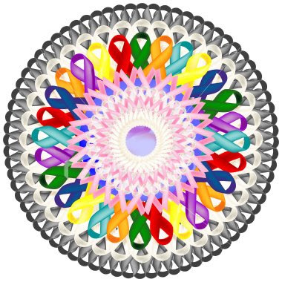

A Time of Remembrance and Celebration:
Remembering Those Who Have Lost Their Battle Against Cancer and Celebrating Those Who Have Survived

Trinity United Methodist Church
407 Duquesne Avenue
Trafford, PA 15085
October 25, 2014
4:00 p.m. to 7:00 p.m.

Join us for remembrance, celebration,
encouragement, food and fellowship

Call 412-373-0835, Option 7
for reservations and/or more information
or email Stephanie at tumc407@verizon.net

A Time of Remembrance and Celebration:
Remembering Those Who Have Lost Their Battle Against Cancer and Celebrating Those Who Have Survived

Trinity United Methodist Church
407 Duquesne Avenue
Trafford, PA 15085
October 25, 2014
4:00 p.m. to 7:00 p.m.

Join us for remembrance, celebration,
encouragement, food and fellowship

Call 412-373-0835, Option 7
for reservations and/or more information
or email Stephanie at tumc407@verizon.net

